

Test Cases & RESULTS

Software Developer - Music Player



Contents

Summary 3

Evidence 6

1.1: ‘Home’ view. 6

2.1a: ‘Home’ view about to click ‘All Songs’ button. 7

2.1b: ‘All Songs’ view after clicking the ‘All Songs’ button from the ‘Home’ view. 7

2.2a: ‘Home’ view about to click ‘My Playlists’ button. 8

2.2b: ‘My Playlists’ view after clicking the ‘My Playlists’ button from the ‘Home’ view. 8

2.3a: ‘Home’ view about to click ‘Search’ button. 9

2.3b: ‘Search’ view after clicking the ‘Search’ button from the ‘Home’ view. 9

2.4a: ‘All Songs’ view about to click ‘Home’ button. 10

2.4b: ‘Home’ view after clicking the ‘Home’ button from the ‘All Songs’ view. 10

2.5a: ‘All Songs’ view about to click ‘String Quartet No 14 in D minor’ song button. 11

2.5b: ‘Player’ view after clicking the ‘String Quartet No 14 in D minor’ song button from the ‘All Songs’ view. 11

2.6a: ‘Search Results’ view after searching for ‘franz’ and getting back related songs. 12

2.6b: ‘Player’ view after clicking the ‘Ave Maria’ song button from the ‘Search Results’ view. 12

2.7a: ‘My Playlist’ view about to click the ‘My fav’s’ playlist button. 13

2.7b: ‘Player’ view after clicking the ‘My fav’s’’ playlist button from the ‘My Playlist’ view. 13

3.1a: ‘Search’ view about to search for the term ‘franz’. 14

3.1b: ‘Search Results’ view after searching for ‘franz’ and getting back related songs. 14

3.2a: ‘Search’ view about to search for the term ‘star’. 15

3.2b: ‘Search Results’ view after searching for ‘star’ and informed there are no results for that search. 15

5.1a: ‘Player’ view loaded with the song I selected. 16

5.1b: ‘Player’ view loaded with the song I selected, now playing the song after I hit the play button. Chromium shows that sound is coming from the tab. 17

5.1c: ‘Player’ view loaded with the song I selected, now paused after hitting the pause button. 18

5.1d: ‘Player’ view loaded with the song I selected, now continued playing from the point I hit the pause button. 19

5.2a: ‘Player’ view loaded with the playlist I selected, about to click the ‘next’ button. 20

5.2b: ’Player’ view loaded with the playlist I selected, now on the second song in the playlist after clicking the ‘next’ button. 20

5.3a: ‘Player’ view loaded with the playlist I selected, on the second song in the playlist, about to click the ‘previous’ button. 21

5.3b: ’Player’ view loaded with the playlist I selected, now on the first song in the playlist after clicking the ‘previous’ button. 21

5.4a: ‘Player’ view loaded with the playlist I selected, about to click the ‘previous’ button. 22

5.4b: ’Player’ view loaded with the playlist I selected, now on the last song in the playlist after clicking the ‘previous’ button, about to click the next button. 22

5.4c: ‘Player’ view loaded with the playlist I selected, now on the first song in the playlist after clicking the ‘next’ button. 23

# Summary

|  |  |  |  |  |  |
| --- | --- | --- | --- | --- | --- |
| **Test Case ID** | **Test Description** | **Test Steps (Numbered) & Test Data (Bullet Pointed)** | **Expected Outcome** | **Actual Results**  ***(Evidence provided on following pages)*** | **Pass / Fail** |
| **1.0 Basic Application** | | | | | |
| 1.1 | On start-up, the application opens user to the ‘Home’ view. | 1. Open the application. | User sees the application open and the home view is displayed. | As Expected. | Pass |
| 1.2 | After 30 seconds without an input from user, the application will switch to idle mode. | 1. Open the application. 2. Don’t interact with the application for 30 seconds. | User sees the application enter idle mode and the display screen will switch off. |  |  |
| 1.3 | From the ‘All Songs’ view and the ‘Search Results’ view, user is able to order the songs displayed by ‘title’ or ‘album’. | 1. Open the application. 2. Click on the ‘All Songs’ button on the display screen. 3. Click the ‘order’ button at the top right of the display screen. | User can change the order the songs are displayed. |  |  |
| **2.0 Navigation** | | | | | |
| 2.1 | From the ‘Home’ view, user is able to navigate to the ‘All Songs’ view. | 1. Open the application. 2. Click on the ‘All Songs’ button on the display screen. | User can click the ‘All Songs’ button and navigate to the ‘All Songs’ view. | As Expected. | Pass |
| 2.2 | From the ‘Home’ view, user is able to navigate to the ‘My Playlists’ view. | 1. Open the application. 2. Click on the ‘My Playlists’ button on the display screen. | User can click the ‘My Playlists’ button and navigate to the ‘My Playlists’ view. | As Expected. | Pass |
| 2.3 | From the ‘Home’ view, user is able to navigate to the ‘Search’ view. | 1. Open the application. 2. Click on the ‘Search’ button on the display screen. | User can click the ‘Search’ button and navigate to the ‘Search’ view. | As Expected. | Pass |
| 2.4 | From any view, user is able to navigate to the ‘Home’ view. | 1. Open the application. 2. Click on the ‘All Songs’ button on the display screen. 3. Click on the ‘Home’ button located at the bottom right of the device. | User can click the ‘Home’ button and navigate to the ‘Home’ view. | As Expected. | Pass |
| 2.5 | From the ‘All Songs’ view, user is able to click a song to open it in the ‘Player’ view. | 1. Open the application. 2. Click on the ‘All Songs’ button on the display screen. 3. Click on one of the songs, e.g. ‘String Quartet No 14 in D minor’. | User can click the song and navigate to the ‘Player’ view from the ‘All Songs’ view. | As Expected. | Pass |
| 2.6 | From the ‘Search Results’ view, user is able to click a song to open it in the ‘Player’ view. *See 3.0 for more details regarding search.* | 1. Open the application. 2. Click on the ‘Search’ button on the display screen. 3. Input a search term and click the search button / press Enter. 4. Click on one of the songs, e.g. ‘Ave Maria’.  * Search term: ‘franz’ | User can click the song and navigate to the ‘Player’ view from the ‘Search Results’ view. | As Expected. | Pass |
| 2.7 | From the ‘My Playlists’ view, user is able to click a playlist to open it in the ‘Player’ view. | 1. Open the application. 2. Click on the ‘My Playlists’ button on the display screen. 3. Click on one of the playlists, e.g. ‘My fav’s’. | User can click the playlist and navigate to the ‘Player’ view from the ‘My Playlists’ view. |  |  |
| **3.0 Search** | | | | | |
| 3.1 | From the ‘Search’ view, user is able to input a search term and get the results for that search. | 1. Open the application. 2. Click on the ‘Search’ button on the display screen. 3. Input a search term and click the search button / press Enter.  * Search term: ‘franz’ | User can, from the ‘Search’ view, input a search and find songs related to their search. | As Expected. | Pass |
| 3.2 | From the ‘Search’ view, user is able to input a search term and are informed that there are no results related to their search. | 1. Open the application. 2. Click on the ‘Search’ button on the display screen. 3. Input an incorrect search term and click the search button / press Enter.  * Search term: ‘star’ | User can, from the ‘Search’ view, input a search and are informed that there are no results related to their search. | As Expected. | Pass |
| **4.0 Playlist Editor** | | | | | |
|  |  |  |  |  |  |
| **5.0 Player / Media Buttons** | | | | | |
| 5.1 | From the ‘Player view’, user is able to play / pause the selected song. | 1. Open the application. 2. Click on the ‘All Songs’ button on the display screen. 3. Click on one of the songs, e.g. ‘String Quartet No 14 in D minor’. 4. Click the ‘play’ button. 5. Listen for a while. 6. Click the ‘pause’ button. 7. Click the ‘play’ button and the song continues from where it was paused. | User can select a song, listen to the song, and control playback using the player. | As Expected. | Pass |
| 5.2 | From the ‘Player view’, when in a playlist, user is able to skip to the next song. | 1. Open the application. 2. Click on the ‘My Playlists’ button on the display screen. 3. Click on one of the playlists, e.g. ‘My fav’s’. 4. Click the ‘next’ button. | User can select a playlist, and select the next song in the playlist. | As Expected. | Pass |
| 5.3 | From the ‘Player view’, when in a playlist, user is able to return to the previous song. | 1. Open the application. 2. Click on the ‘My Playlists’ button on the display screen. 3. Click on one of the playlists, e.g. ‘My fav’s’. 4. Click the ‘next’ button. 5. Click the ‘previous’ button. | User can select a playlist, and select the previous song in the playlist. | As Expected. | Pass |
| 5.4 | From the ‘Player view’, when in a playlist, the ‘previous’ and ‘next’ buttons loop through the playlist. | 1. Open the application. 2. Click on the ‘My Playlists’ button on the display screen. 3. Click on one of the playlists, e.g. ‘My fav’s’. 4. Click the ‘previous’ button. 5. Click the ‘next’ button. | User can select a playlist, and select the next or previous song in the playlist looping through to the start or end respectively. | As Expected. | Pass |
| 5.5 | From the ‘Player view’, when in a playlist, user is able to shuffle to a random song. |  |  |  |  |
| 5.6 | From the ‘Player view’, when in a playlist, the position in the playlist is shown at the bottom right of the display screen. |  |  |  |  |
| 5.7 | From the ‘Player view’, when in a single song, the user is only able to interact with the pause/play button (the previous, next, and shuffle buttons are all disabled). |  |  |  |  |

# Evidence

## 1.1: ‘Home’ view.

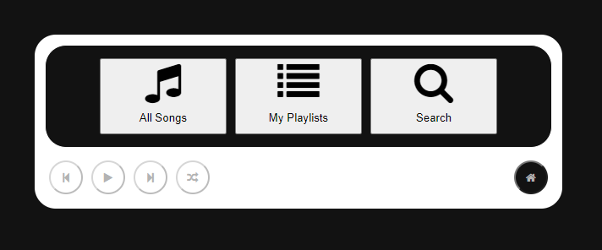

## 2.1a: ‘Home’ view about to click ‘All Songs’ button.

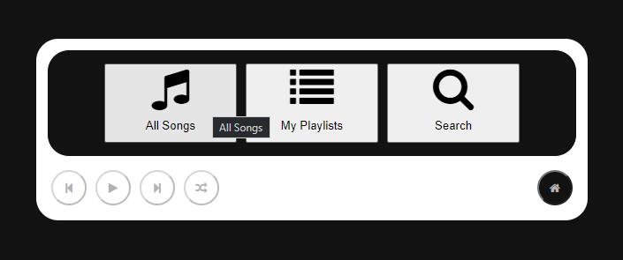

## 2.1b: ‘All Songs’ view after clicking the ‘All Songs’ button from the ‘Home’ view.

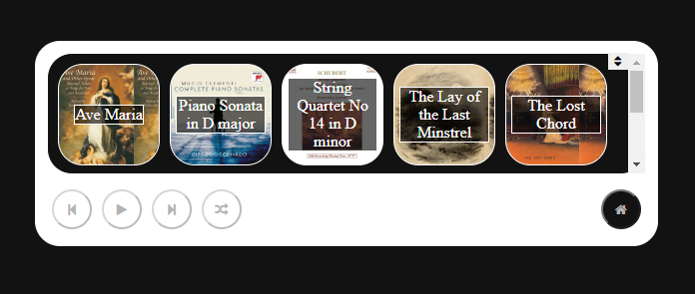

## 2.2a: ‘Home’ view about to click ‘My Playlists’ button.

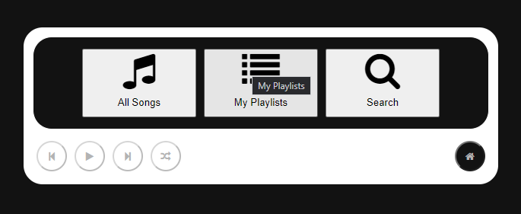

## 2.2b: ‘My Playlists’ view after clicking the ‘My Playlists’ button from the ‘Home’ view.

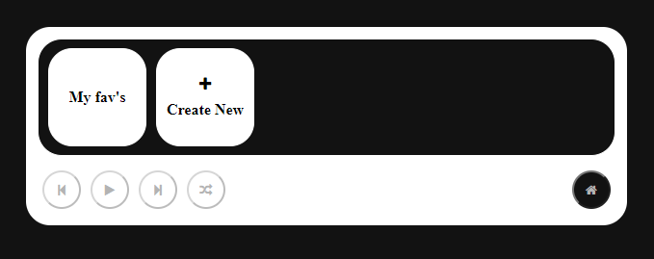

## 2.3a: ‘Home’ view about to click ‘Search’ button.

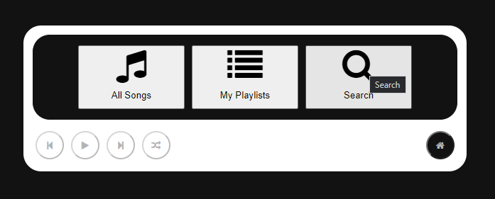

## 2.3b: ‘Search’ view after clicking the ‘Search’ button from the ‘Home’ view.

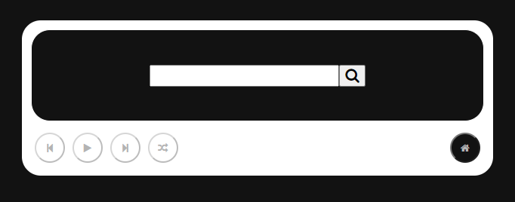

## 2.4a: ‘All Songs’ view about to click ‘Home’ button.

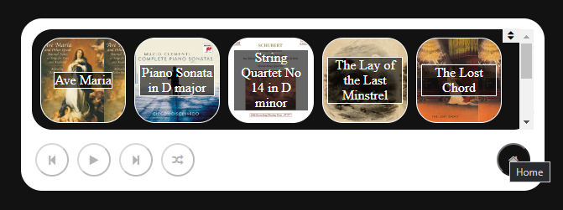

## 2.4b: ‘Home’ view after clicking the ‘Home’ button from the ‘All Songs’ view.



## 2.5a: ‘All Songs’ view about to click ‘String Quartet No 14 in D minor’ song button.



## 2.5b: ‘Player’ view after clicking the ‘String Quartet No 14 in D minor’ song button from the ‘All Songs’ view.

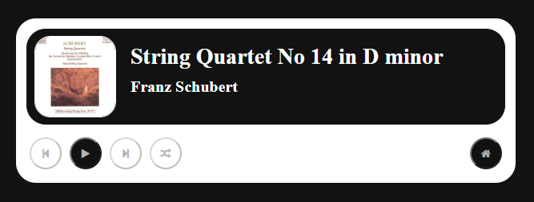

## 2.6a: ‘Search Results’ view after searching for ‘franz’ and getting back related songs.

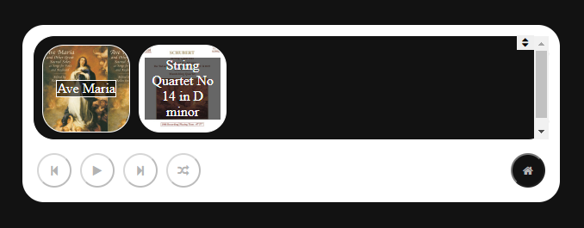

## 2.6b: ‘Player’ view after clicking the ‘Ave Maria’ song button from the ‘Search Results’ view.

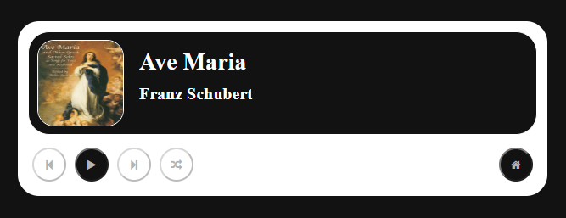

## 2.7a: ‘My Playlist’ view about to click the ‘My fav’s’ playlist button.



## 2.7b: ‘Player’ view after clicking the ‘My fav’s’’ playlist button from the ‘My Playlist’ view.

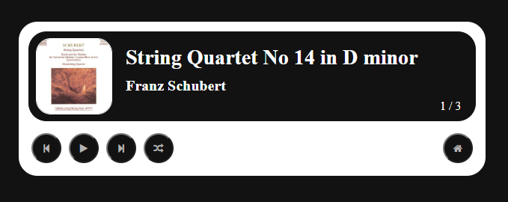

## 3.1a: ‘Search’ view about to search for the term ‘franz’.

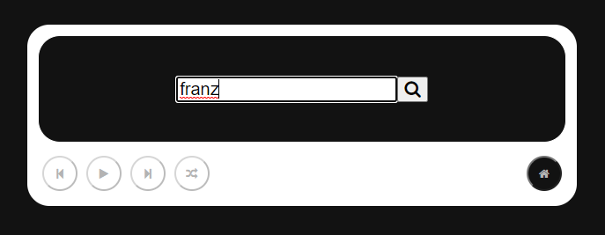

## 3.1b: ‘Search Results’ view after searching for ‘franz’ and getting back related songs.



## 3.2a: ‘Search’ view about to search for the term ‘star’.

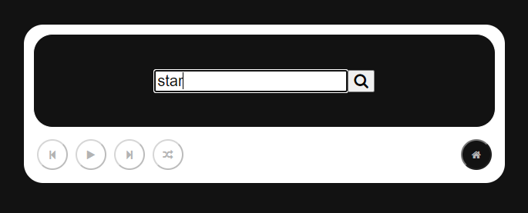

## 3.2b: ‘Search Results’ view after searching for ‘star’ and informed there are no results for that search.

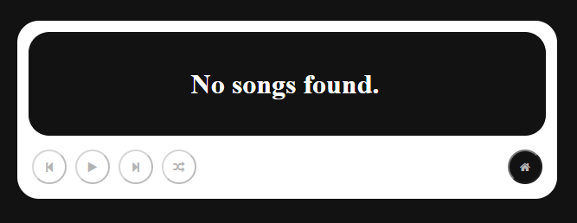

## 5.1a: ‘Player’ view loaded with the song I selected.

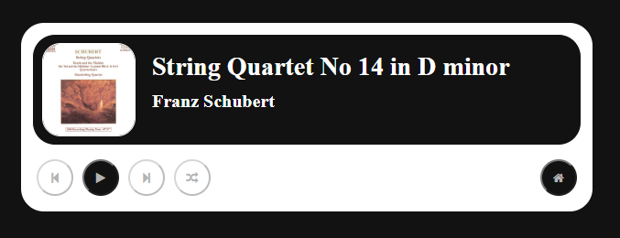

## 5.1b: ‘Player’ view loaded with the song I selected, now playing the song after I hit the play button. Chromium shows that sound is coming from the tab.

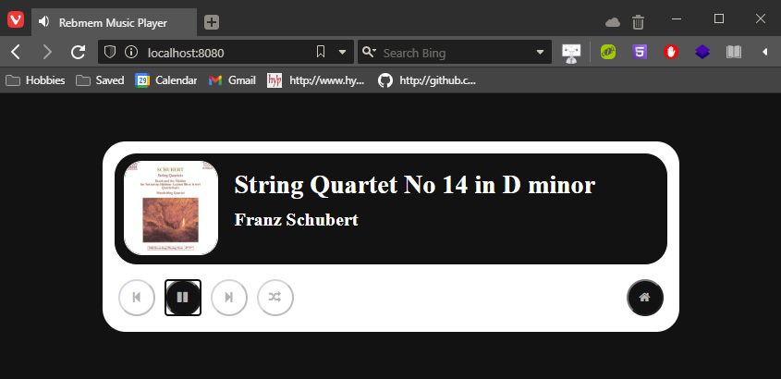

## 5.1c: ‘Player’ view loaded with the song I selected, now paused after hitting the pause button.

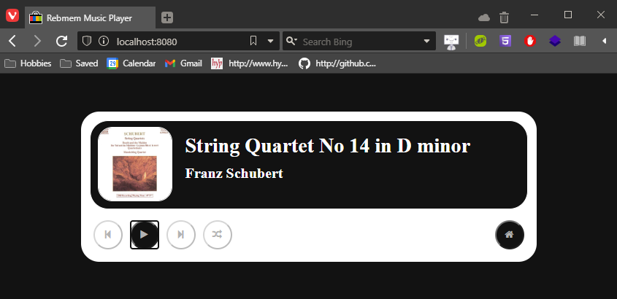

## 5.1d: ‘Player’ view loaded with the song I selected, now continued playing from the point I hit the pause button.

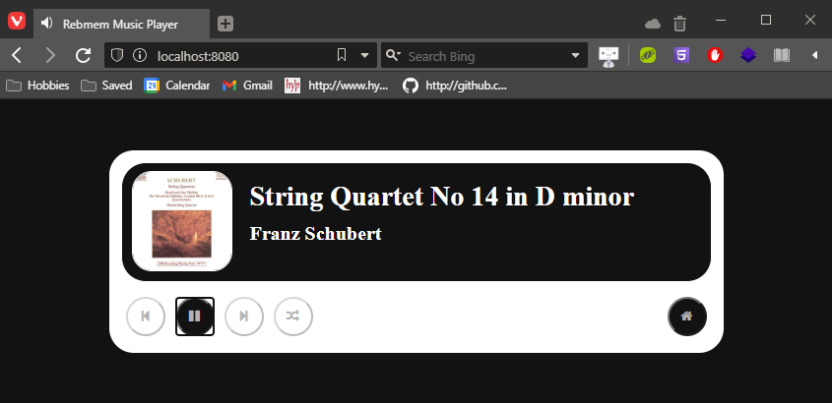

## 5.2a: ‘Player’ view loaded with the playlist I selected, about to click the ‘next’ button.

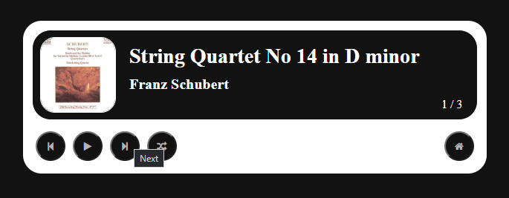

## 5.2b: ’Player’ view loaded with the playlist I selected, now on the second song in the playlist after clicking the ‘next’ button.

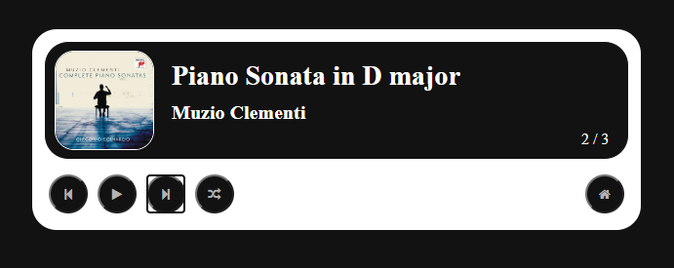

## 5.3a: ‘Player’ view loaded with the playlist I selected, on the second song in the playlist, about to click the ‘previous’ button.

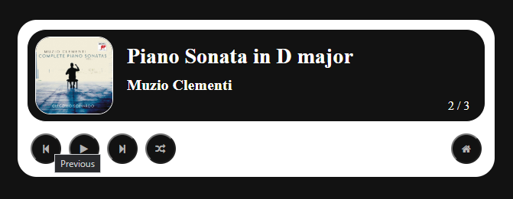

## 5.3b: ’Player’ view loaded with the playlist I selected, now on the first song in the playlist after clicking the ‘previous’ button.

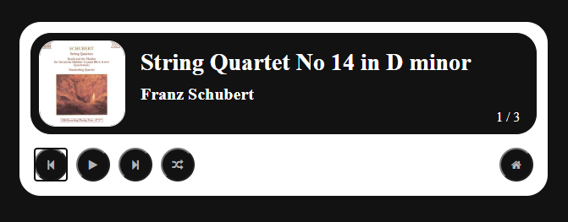

## 5.4a: ‘Player’ view loaded with the playlist I selected, about to click the ‘previous’ button.

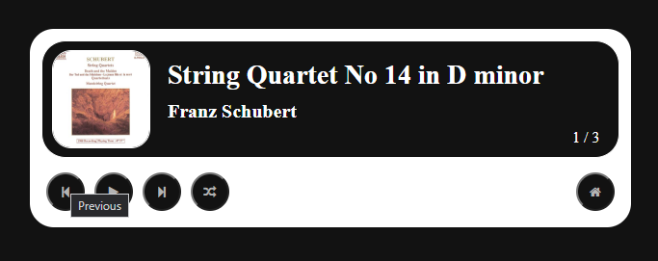

## 5.4b: ’Player’ view loaded with the playlist I selected, now on the last song in the playlist after clicking the ‘previous’ button, about to click the next button.

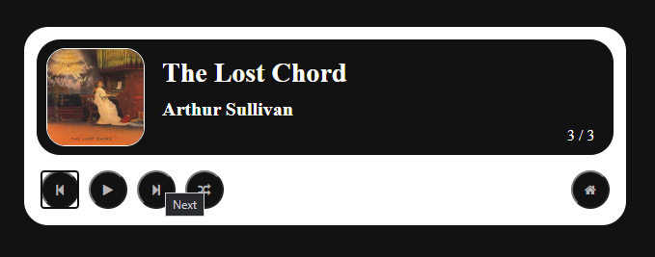

## 5.4c: ‘Player’ view loaded with the playlist I selected, now on the first song in the playlist after clicking the ‘next’ button.

